Lolita

First American edition, G.P. Putnam’s Sons,
New York, 21 Jul 58.

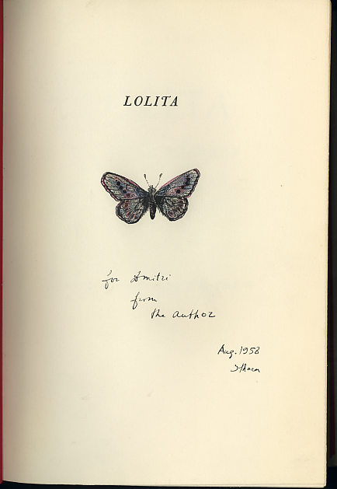

A meticulously drawn butterfly belonging to a plausible genus and species.

